**I. PROJECT DETAILS**

|  |  |
| --- | --- |
| Project Name | Employee Management System |
| Project Sponsor | Frank Chin |
| Project Manager / Developer | John Allen Hidalgo |
| Phone Number |  |
| Expected Start Date | 12/19/2022 |
| Expected Completion Date | 2/20/2023 |

**II. PROJECT DESCRIPTION**

This is the Employee management of the Frank Chins Company

**II.1 OBJECTIVE AND GOALS**

To develop a Employee management System for the company

**II.2 SCOPE**

Employee`s profile

**II.3** **Specifications / Features**

Employee profile   
- Create user Data

* Log in feature
* Edit Employees Data
* Update Employees Data
* Delete Employees Data

**II.4** **CONSTRAINTS, ASSUMPTIONS, RISKS AND DEPENDENCIES**

|  |  |
| --- | --- |
| Constraints | - Always short of time due to other jobs  - Device is outdated and cannot finish the task |
| Assumptions | Sample Employees Data |
| Risks and Dependencies | Security , Reliability , Consistency, Data Base. |
|  |  |

**III. Flowchart**

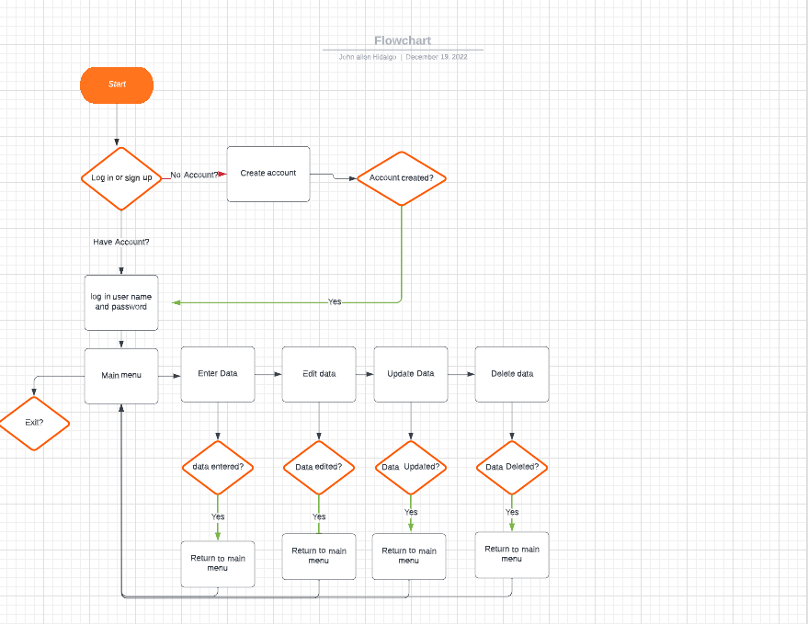

**IV. KEY STAKE HOLDERS**

|  |  |
| --- | --- |
| Client | Frank Chin |
| Sponsor | Frank Chin |
| Project manager | John Allen Hidalgo |
| Project developer | John Allen Hidalgo |

**V. MILESTONES**

|  |  |  |
| --- | --- | --- |
| **Milestones [Example]** | **Start Date** | **End Date** |
| Initial Design, Prototype, and Project Setup | 2/15/22 | 2/15/22 |
| App Layout and User Interface Design | 2/15/22 | 2/16/22 |
| 1st Development Phase | 2/16/22 | 2/21/22 |
| Client Update Demo | 2/22/22 | 2/22/22 |
| 2nd Development Phase | 2/22/22 | 2/26/22 |
| Client Final Presentation | 2/26/22 | 2/26/22 |
| Final App Testing, Revisions, and Calibrations | 2/26/22 | 2/28/22 |
| **Project Completion and Release** | **3/01/22** | **3/01/22** |

**VI. APPROVAL SIGNATURES**

|  |  |
| --- | --- |
| [Signature] | [Signature] |
| [Name]  *Project Client* | [Name]  *Project Sponsor* |